# DD2424 Deep Learning in Data Science

## Assignment 1 Report

### Yage Hao ([yage@kth.se](mailto:yage@kth.se))

#### I. Introduction

In this assignment, we intend to classify images into multiple categories by constructing a one-layer neural network. Our dataset is CIFAR-10 which has already been split into training set, validation set and testing set. Each one includes data (observations) and labels (results).

#### II. Code Explanation

In general, we applied mini-batch gradient descent algorithm on the cross-entropy loss with L2 regularization term. Full detailed mathematical formulas are provided in the ‘Background’ part of the assignment document.

In detail, we first defined three function during the data preprocessing step. They are ‘loadBatch’, ‘unpickle’ and ‘proprocess’.

Then, we defined a class named ‘Classifier’, in which we realized the neural network and the mini-batch gradient descent algorithm. In this class, we defined the following methods:

* evaluateClassifier: Compute p=softmax(s).
* computeCost: Compute cost function.
* computeAccuracy: Compute the accuracy of the network's predictions.
* computeGradients: Evaluate the gradients of the cost function w.r.t. W and b.
* computeGradientsNum: Numerically evaluate gradients.
* performPlot: Plot performance curve of training set and validation set.
* minibatchGD: Model training with mini-batch gradient descent.
* Visualization: visualize the weight matrix.

Specially, by comparing the results obtained by function ‘computeGradients’ and ‘computeGradientsNum’, we received the same derivatives (in the level of ${10}^{-6}$) through numerical method and analytical method.

Finally, in the main function, we picked four sets of parameters for the model and output the training accuracy, validation accuracy, testing accuracy and plots of the weight matrix for different classes.

#### III. Results

* Case 1: Lambda=0, n_epochs=40, n_batch=100, eta=.1

training mean: 0.50916

training std: 0.03605676635529037

validation mean: 0.27493

validation std: 0.007513461252977887

testing mean: 0.27874000000000004

testing std: 0.007938160996099794

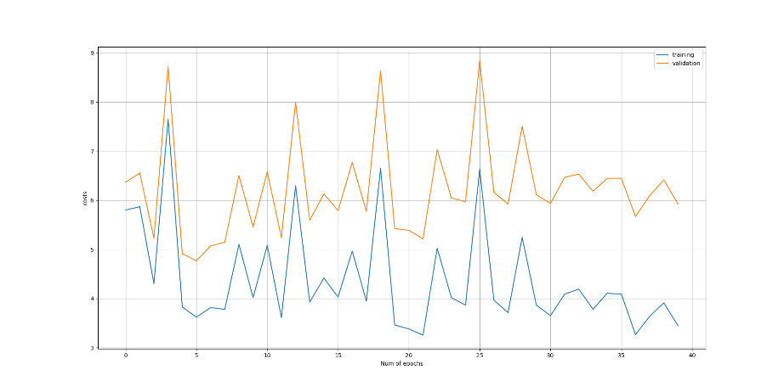

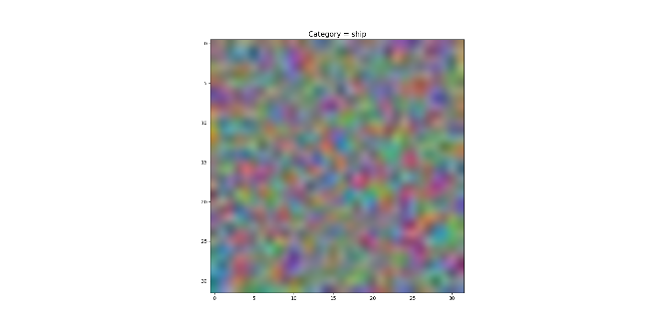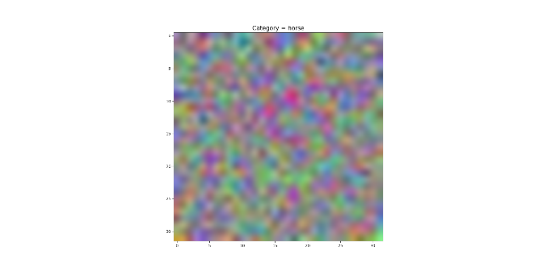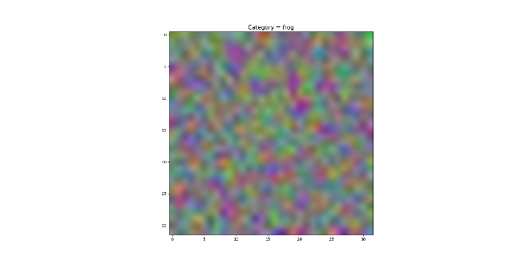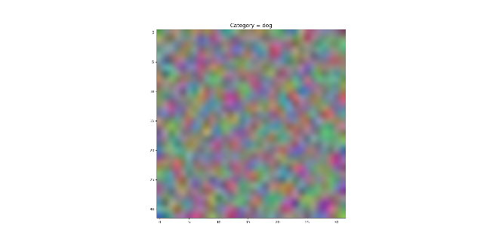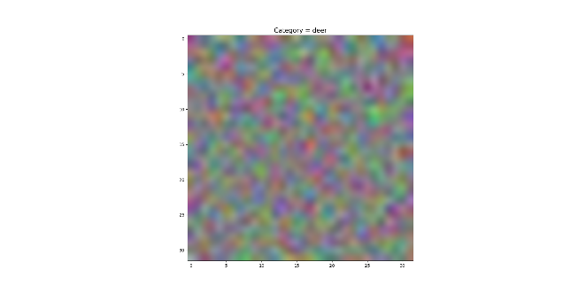

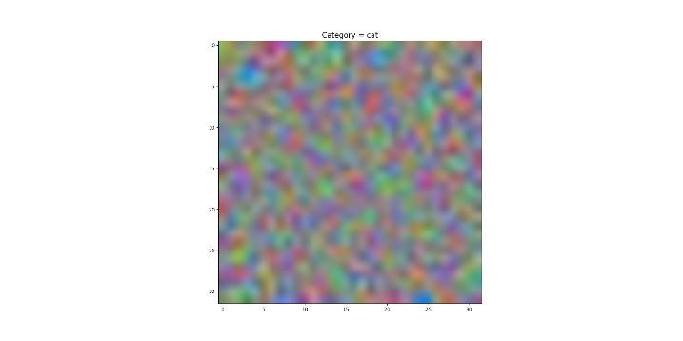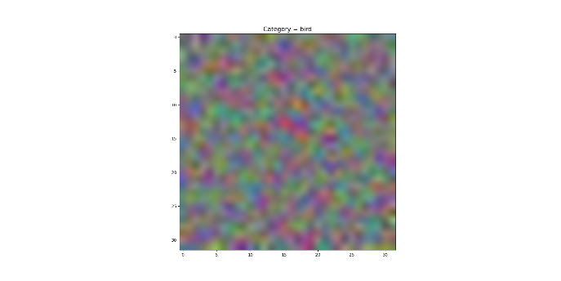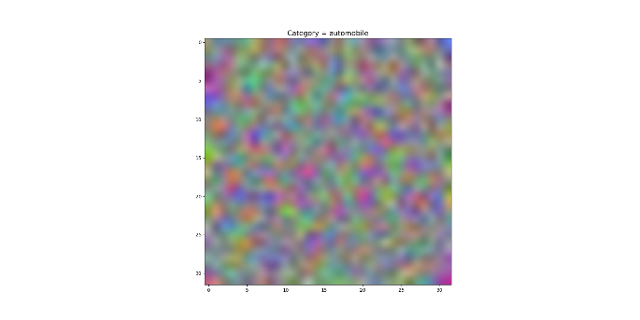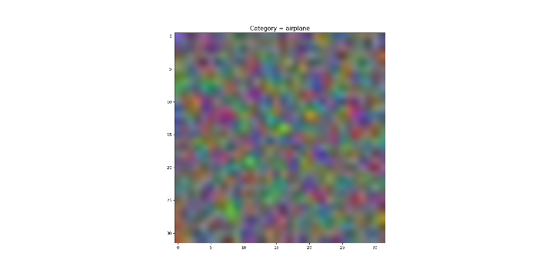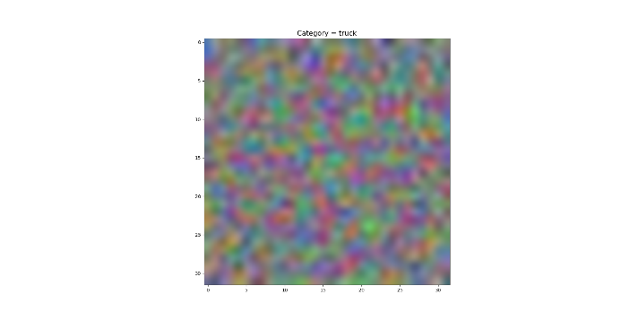

* Case 2: Lambda=0, n_epochs=40, n_batch=100, eta=.001

training mean: 0.7042900000000001

training std: 0.007924449507694522

validation mean: 0.27424000000000004

validation std: 0.0014691494137765598

testing mean: 0.28001999999999994

testing std: 0.0017837040113202656

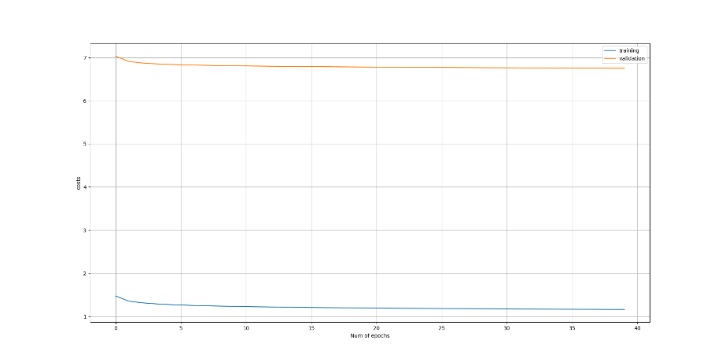

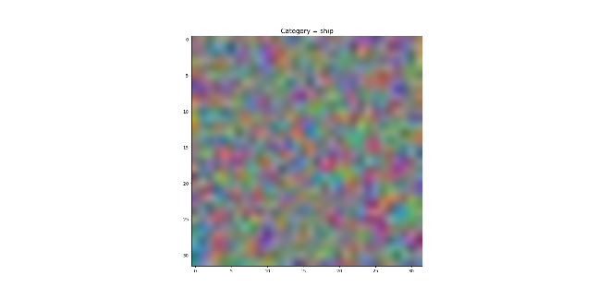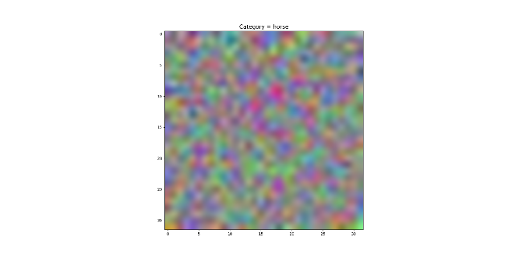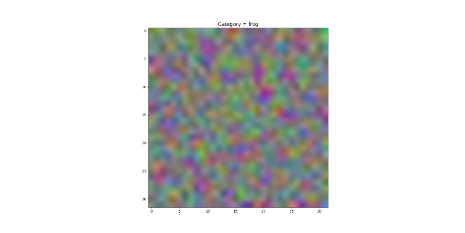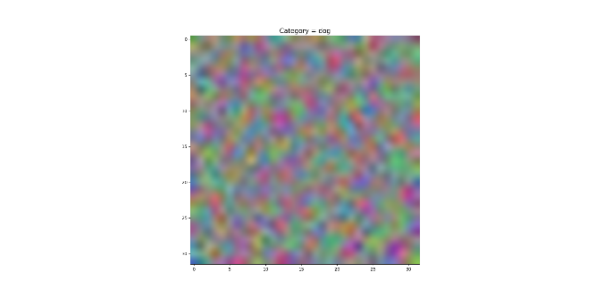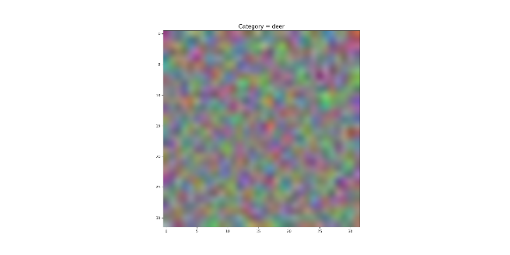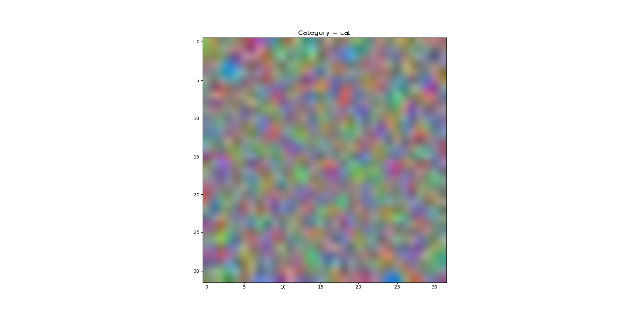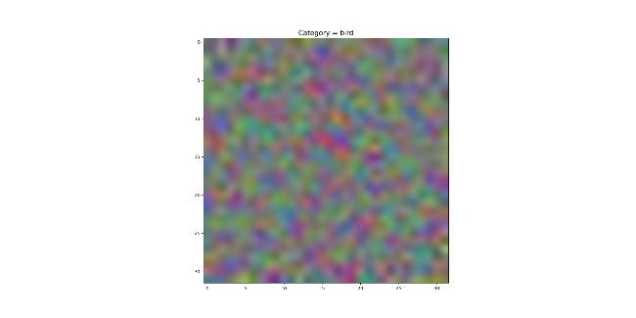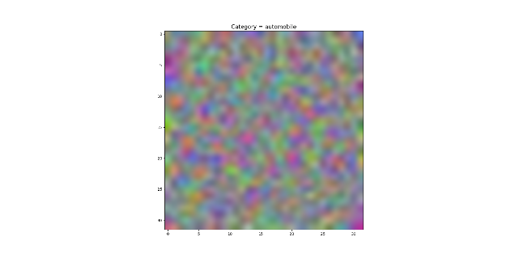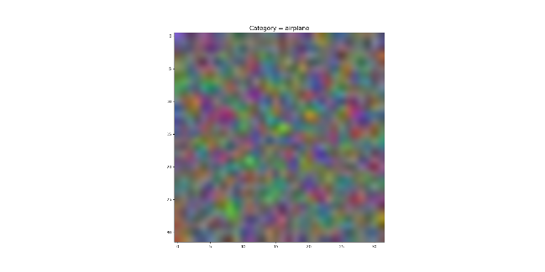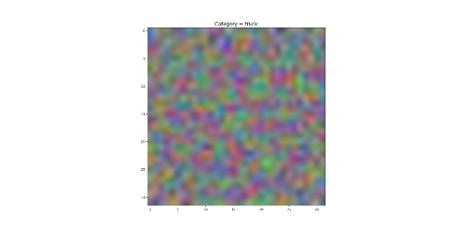

* Case 3: Lambda=.1, n_epochs=40, n_batch=100, eta=.001

training mean: 0.5267999999999999

training std: 0.08386338891316045

validation mean: 0.36319

validation std: 0.03479555862462909

testing mean: 0.36891

testing std: 0.03292337923117857

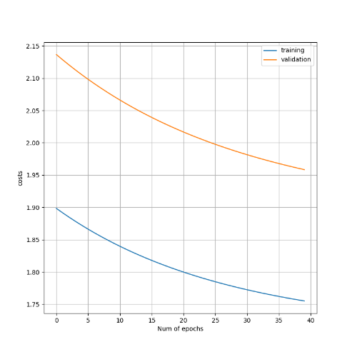

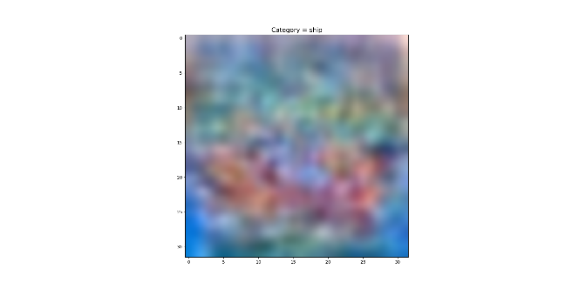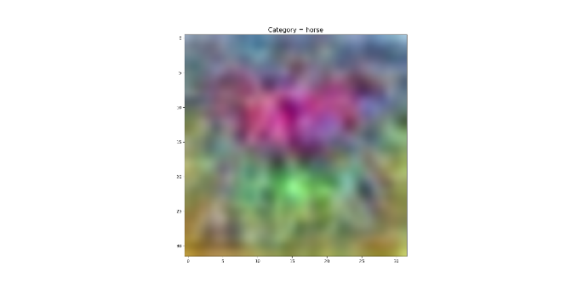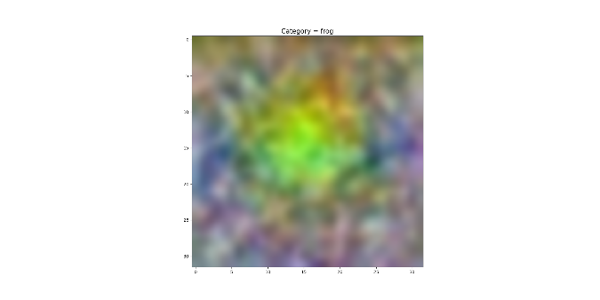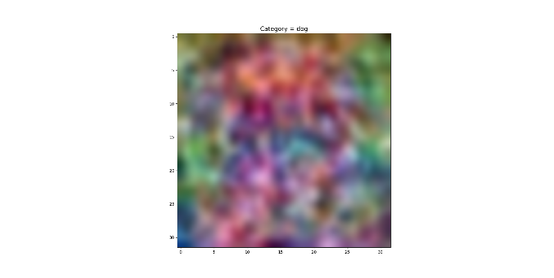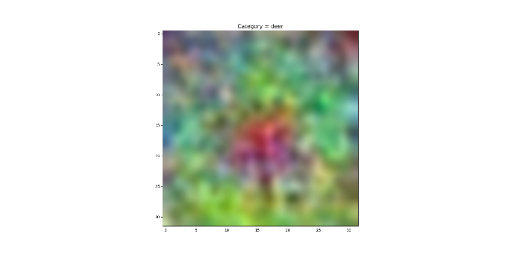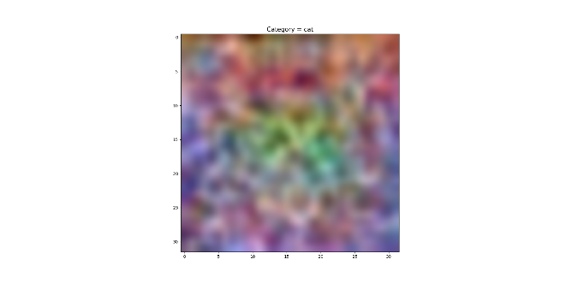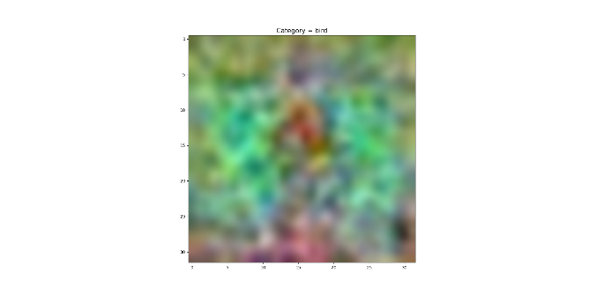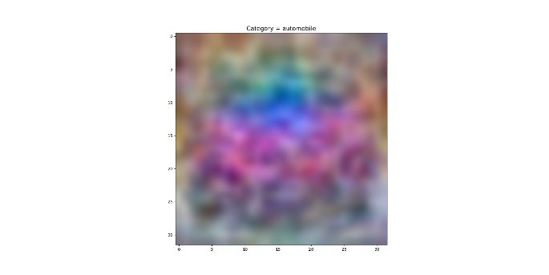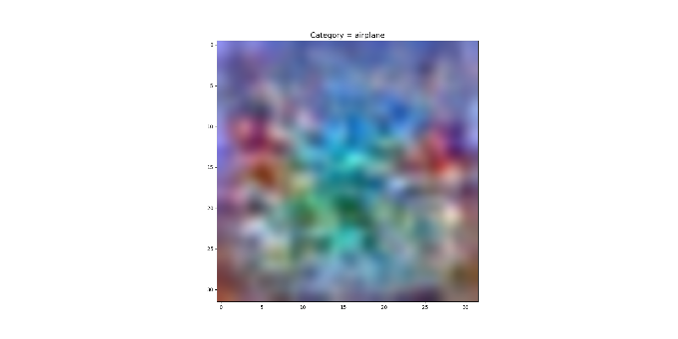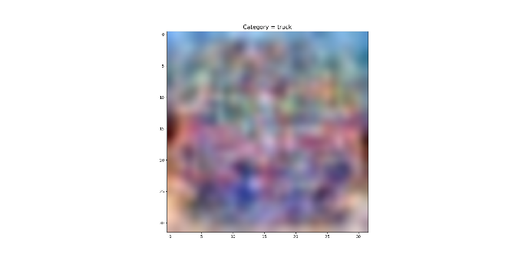

* Case 4: Lambda=1, n_epochs=40, n_batch=100, eta=.001

training mean: 0.39948

training std: 0.0008749857141690874

validation mean: 0.36696

validation std: 0.0014582180906846521

testing mean: 0.37781

testing std: 0.002151023012429204

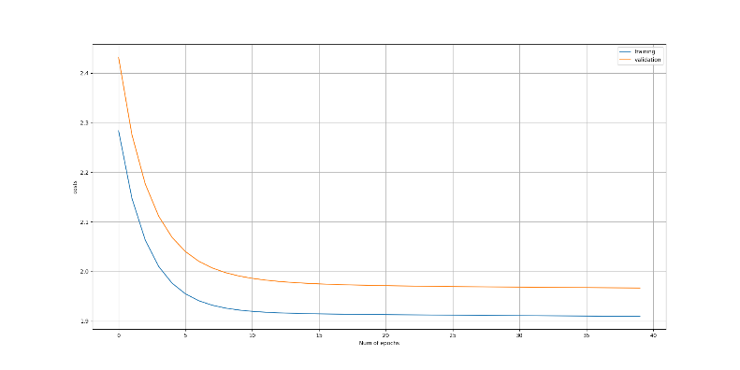

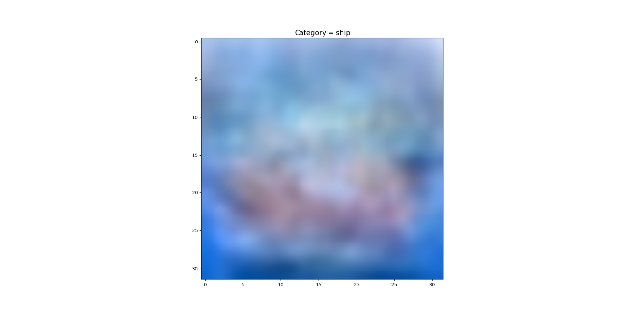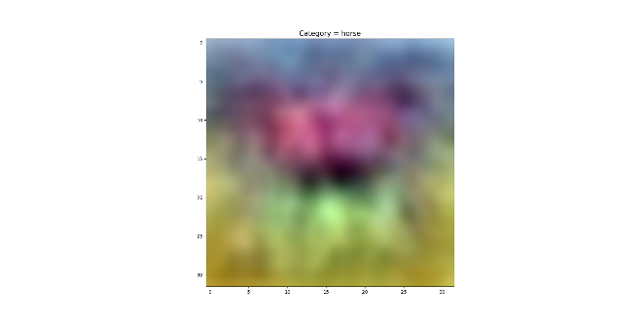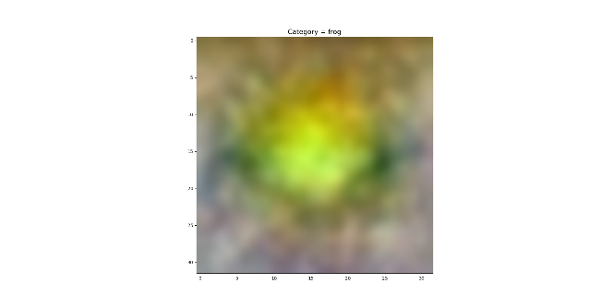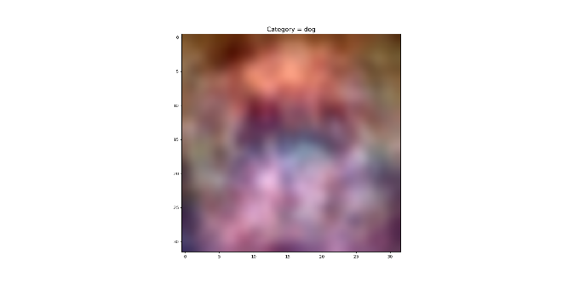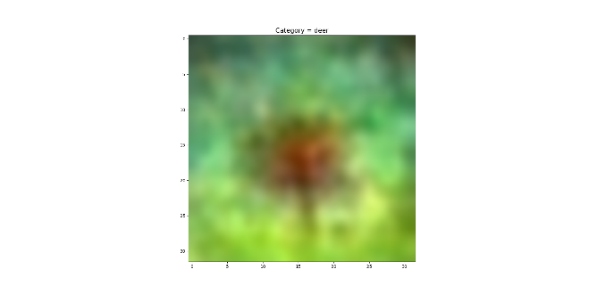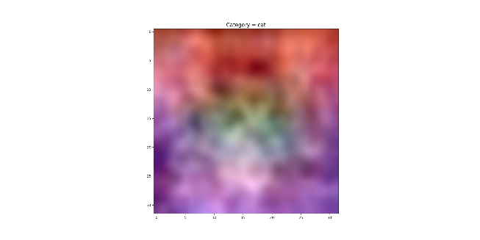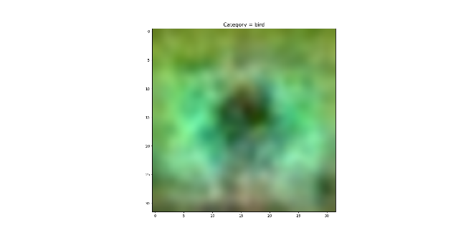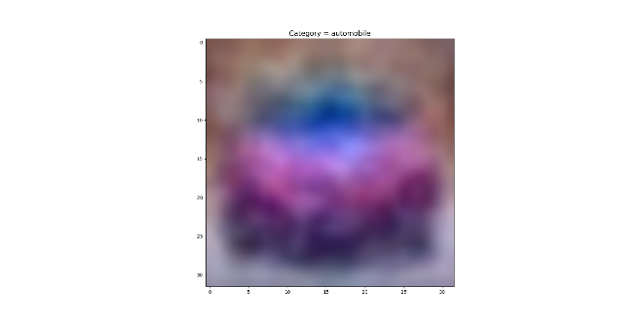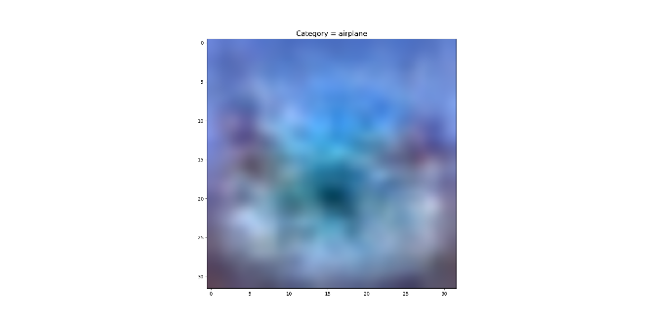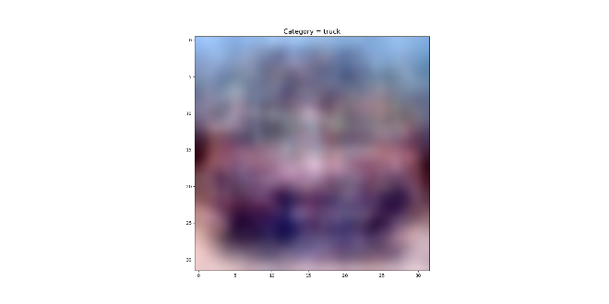

#### IV. Conclusion

The most important conclusion is that the performance of using a one-layer neural network with mini-batch gradient descent algorithm to classify multiple categorical images is not good as shown in the test accuracy with different parameters.

Comparing the results of Case 3 and Case 4, we noticed that increasing the regularization parameter lambda led to a poor classification power, while we also know that the overfitting problem can be avoided through adding the regularization term.

Comparing the results of Case 1 and Case 2, we noticed that reducing the learning rate eta led to a stronger classification power. Especially by observing the unstable cost plot in Case 1, we find that a large learning rate can hardly descent to a local optimum point.